  For office use only
  T1 | ________________
  T2 | ________________
  T3 | ________________
  T4 | ________________
  Team Control Number
  20048
  Problem Chosen
  A
  For office use only
  F1 | ________________
  F2 | ________________
  F3 | ________________
  F4 | ________________
2013
Mathematical Contest in Modeling (MCM/ICM) Summary Sheet
(Attach a copy of this page to your solution paper.)

Summery
在烘烤产品时，经常出现产品受热不均匀和烤箱的空间没有得到充分利用的现象。本文建立了两个模型用于确定最好的平底锅，使得产品在不至于局部过热的条件下又能让烤箱的空间得到充分的利用。
While baking a product, it is a commonplace phenomenon that the product is not evenly heated and the space in an oven is not used efficiently. In this thesis two models are thus established to determine the optimum pan for the purpose of making full use of the space in an oven under the condition that the product is not locally overcooked.
首先在查找相关文献的基础上，结合自然界中传递过程中的普遍关系，传递过程速率与过程的推动力成正比，与过程的阻力成反比这一规律建立了受热分布模型—模型一，得到了圆形、矩形以及两者之间的中间形状下平底锅的边缘单位面积受到的热量与位置分布的四维图。结果表明，矩形平底锅的四个角落容易使产品产生局部过热的现象，而圆形平底锅中的产品受热较为均匀。
As the first step, the temperature distribution model (the first model) is developed on the basis of related documents combined with common relations in transfer process in nature, and the rule that in the transfer process the rate is proportional to the driving force of the process and is inversely proportional to the resistance of the process. Then a NavInfo is built by this model showing the distribution of edge temperature with regard to time and location for pans which are different in shapes- rectangular to circular and other shapes in between. The result demonstrates that the four corners of the rectangular pan tend to locally overcook the product while in a circular one the product is evenly heated.
在模型一的基础上，我们有了一个这样的认识，形状越接近圆形的锅受热越均匀。在此基础上，我们定义了任意形状物体的圆度，并把圆度作为衡量平底锅受热均匀性的指标。代表平底锅的数目,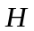为热量分布均匀度,为权重系数。定义综合函数：
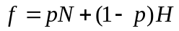
Based on the first model, a thought has been hereby obtained that the closer the pan is to circular in shape, the more even it will be when the pan is being heated. Under the conditions above, the circular degree of objects of arbitrary shape is defined and is used as an index to measure the heating uniformity of the pan. N stands for the number of pans, H for the heat distribution uniformity, and p for the weight coefficient. As the next step, integrated function f is defined:
以综合函数为目标函数，到网上平底锅商店店查找大致尺寸范围建立约束条件，建立非线性整数规划模型—模型二。让权重系数在[0.1,0.9]之间以0.1为步长变化，并求得每个对应的目标函数的最大值及对应的W/L，取使得值最大的作为最优的权重系数。结果表明，当烤箱的W/L接近1，权重系数等于0.7时取得最大值。在最优的权重系数下我们求得最优的平底锅的结果尺寸参数为：
A non-linear integer programming model (the second model) has been built by completing the following work. To start with, f is assigned as the objective function. After that, constraint condition is established by searching for rough range of sizes in online shops selling pans. Afterwards, 0.1 is set as the step change of p in [0.1,0.9], and the maximum value of f which corresponds to p in every condition as well as the corresponding W/L are obtained, and then p which maximizes f is regarded as the optimum weight coefficient. With the optimum weight coefficient, the optimum resulting parameter of the size of pans is:
我们所建立的模型不仅可以用于确定最终的平底锅，还可以用于为平底锅选择匹配效果最好的烤炉。只要知道客户的烤炉的尺寸信息，便可根据我们建立的模型为它设计最佳的平底锅。
The model developed can be used not only to determine the ultimate pan, but also to select the most efficient oven which matches the pan. Once the information of the oven’s size the customer requires is available, the optimum pan can be hereby designed through the model.

关键词：

The Ultimate Brownie Pan

Abstract

1.Introduction
1.1 Outline of our approach
在烘烤产品时，出现局部过热现象，会出现产品拿出来时，若烘烤时间过短，则局部过热的地方已经烤熟，而其它部位还没有熟，若烘烤时间过长，会造成整块产品烤焦的现象。所以说，局部受热不均匀是我们不希望看到的。我们论文的前面一些部分将致力于弄清楚不同形状的产品在烤箱中的受热情况。然而，使得产品受热较为均匀的平底锅的并不一定能使得烤箱的空间得到充分的利用。在论文的后面部分我们将致力于寻找最好的平底锅，使得既能使得产品受热均匀又能让烤箱的空间得到最大限度地利用。为了设计出最好的平底锅，以下工作是我们需要完成的。
The former part of the thesis is committed to make certain the temperature distribution of products of different shapes in an oven. Nevertheless, pan that relatively uniformizes the temperature distribution of the product will not necessarily make full use of the space in an oven. In the latter part, effort is made to find out the optimum pan that makes the product heated evenly and at the same time takes advantage of the space in the oven to the fullest. In order to design the optimum pan, the following tasks must be accomplished.
- 查找前人做过的实验数据，并根据热力学基本原理，建立模型一，推导出矩形、圆形以及两者之间的中间形状的温度分布规律。
1. retrieve the data of experiments carried out before and build the first model according to the basic disciplines of thermodynamics and then deduce the rule of temperature distribution of rectangular, circular and shapes in between.
- 根据模型一得到的温度分布规律，在考虑烘烤产品时温度均匀性的前提下考虑平底锅的结构尺寸。在得到得到最佳平底锅的结构尺寸之前，我们需要到网上商店查找一般烤箱的结构尺寸范围，然后建立约束规划模型—模型二，通过求解模型二来得到最佳的平底锅。
2. consider the structure size of the pan on the basis of the rule of temperature distribution obtained by the first model meanwhile taking into account the temperature uniformity while baking the product. Before the optimum structure size of the pan is acquired, there is a need to search for the average range of the structure size of the pan in online shops, and then a constrained programming model (the second model) must be developed by which to select the optimum pan.
1.2 Assumptions
假设一：假设烤箱在工作过程中性能稳定
这就是说，一方面，烤箱在工作过程中供电电源是稳定的，不会出现断电之类的突发状况。另一方面，烤箱的各个部位正常工作，不发生零件出现故障的现象。如果烤箱不能正常工作，那讨论用它来烘烤产品将是毫无意义的。
The first assumption: the oven performs steadily in the working process.
In other words, on one hand, the power supply of the oven in the working process is steady, excluding any emergency such as a power failure. On the other hand, all the parts of the oven works normally and there is no possibility that components break down. It is completely meaningless to probe into the situation where an oven that can not work normally is used.
假设二：平底锅的长和宽可以认为接近烤箱的长和宽
这一点是基于充分利用烤箱的空间考虑的。当然，小平底锅的形状与大平底锅的形状是可以不相同的，在一般情况下，我们考虑的小平底锅的形状是介于矩形和圆形之间的。
The second assumption: the width and length of the pan can be regarded to be close to those of the oven.
The assumption is made by considering the full use of the space in an oven. It is certain that the shapes of small and large pans can be different and generally, the shape of the small pan taken into account is between rectangular and circular.
假设三：产品在烤箱设定的温度是可以烤熟的
假如烤箱中产品不能烤熟，可能是由于烤箱所能达到的最大温度过低或者是由于产品要达标本身的要求较高导致的。如果不能烤熟的话，那我们讨论其在烤箱内的温度分布情况和设计最好的平底锅将是没有意义的。
The third assumption: the product can be baked to be ripe under the temperature set by the oven.
If the product in the oven fail to be ripe, it is possible that the highest temperature the oven can reach is too low or the product has an even higher requirement for temperature. It is of no meaning to discuss the temperature distribution in the oven and to design the optimum pan if the product can not be baked to be ripe.

Restatement and clarification of the problem
When baking in a rectangular pan heat is concentrated in the 4 corners and the product gets overcooked at the corners (and to a lesser extent at the edges). In a round pan the heat is distributed evenly over the entire outer edge and the product is not overcooked at the edges. However, since most ovens are rectangular in shape using round pans is not efficient with respect to using the space in an oven.To design a ultimate brownie pan which matches the oven and product,we need to accomplish the following tasks:
Task1:Develop a model to show the distribution of heat across the outer edge of a pan for pans of different shapes - rectangular to circular and other shapes in between under the following basic assumptions.
1. A width to length ratio of W/L for the oven which is rectangular in shape.
2. Each pan must have an area of A.
3. Initially two racks in the oven, evenly spaced.
Task2:Develop a model that can be used to select the best type of pan (shape) under the following conditions:
1. Maximize number of pans that can fit in the oven (N)
2. Maximize even distribution of heat (H) for the pan
3. Optimize a combination of conditions (1) and (2) where weights p and (1- p) are assigned to illustrate how the results vary with different values of W/L and p.
Task3:In addition to a MCM formatted solution, prepare a one to two page advertising sheet for the new Brownie Gourmet Magazine highlighting our design and results.
Models and methods
模型一：温度分布模型
自然界中传递过程的普遍规律为：传递过程速率与过程的推动力成正比，与过程的阻力成反比。传热过程速率可表示为：传热速率=传热推动力（温度差）/传热热阻，根据这一原理可以导出导热速率可以表示为【1】：
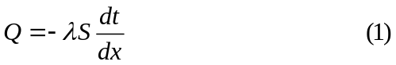
其中为导热系数，为传热截面积。当壁面材料均匀时，导热系数随温度变化不大。但是很多情况下待烘烤产品的材料混合并不均一，为了显示这种变化我们取关于是线性的，对于具体的产品我们建议如果可以的话应当进行实验测定关于的变化关系。
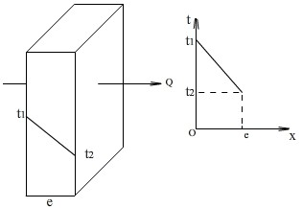
图一
图一所示是一个单层平壁热传导情形，热量由高温侧向低温侧传递。根据(1)积分可得：
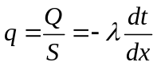
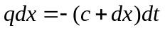
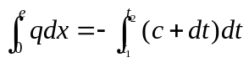
由此可得：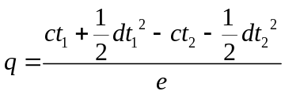
用替换,替换则可以得到单层平壁热传导方程为：
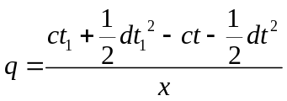
图二所示是长方形产品导热分析图，当Top convective fan speed 和Bottom convective fan speed均为0，设置温度为180摄氏度，baking time为6min时Top/side/bottom温度分别为104/81/101摄氏度。较大的长方体为产品，取其内部以O为顶点的一小长方体作为受热研究对象。

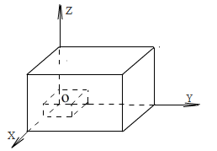
图二
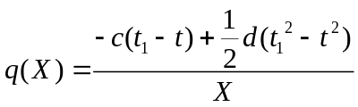

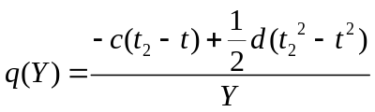
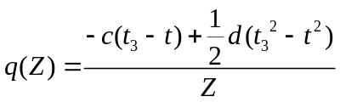
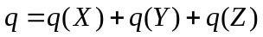

其中，,,分别为微元距面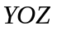，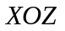,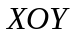面的距离。
为平底锅的面的的平均温度
为平底锅的面的平均温度
为平底锅的面的平均温度
为简化传热过程，取室温。
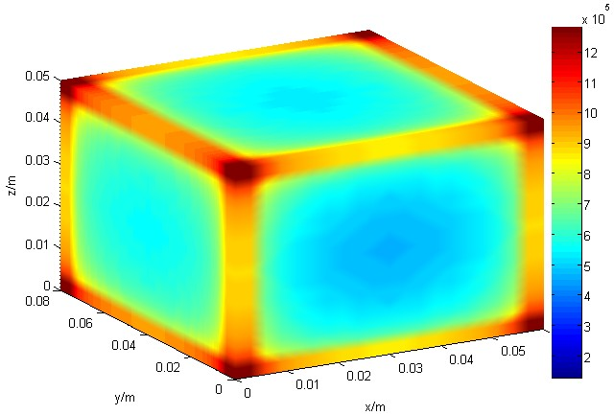
图三
从图三可以直观的看到，矩形平底锅的角落单位面积内所受的热比其它位置要多，所以说矩形平底锅的角落容易产生局部过热的现象。在烘烤产品时，出现局部过热现象，会出现产品拿出来时，若烘烤时间过短，则局部过热的地方已经烤熟，而其它部位还没有熟，若烘烤时间过长，会造成整块产品烤焦的现象。所以说，局部受热不均匀是我们不希望看到的。
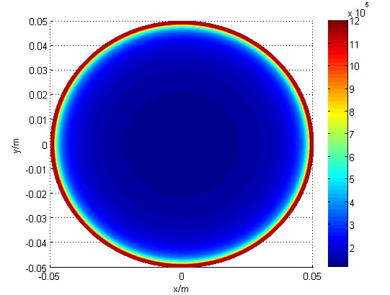
图四
图三所示是圆形平底锅的截面受热图，可以看到，圆形平底锅边缘的受热均匀性好。不会出现矩形平底锅的局部受热不均匀的现象。

模型二：
平底锅形状选择模型
模型的假设
一方面，我们要使得烤炉的两个烤架的空间得到充分的利用，与此同时，我们还要考虑到物体在平底锅上受热的均匀性。一般来说，矩形物体在平底锅上四个角容易出现过热的现象，而圆形平底锅可以避免这种局部过热的现象，也就是说圆形平底锅能够使得烘烤的食物受热更加均匀一些。为了将物体受热均匀性这个指标进行量化，在这里，我们定义圆度的概念。
圆度
对于一个任意形状的物体来说，在化工原理中，物体的球形度定义为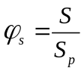，其中为与该颗粒体积相等的圆球的表面积，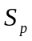为颗粒的表面积。类似地，我们定义圆度。如下图所示，为一个没有厚度的平面物体，其轮廓上任意两点间的距离的最大值为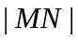，
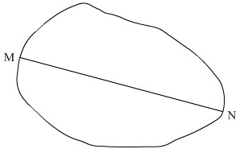
定义圆度为=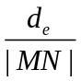,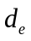为当量直径，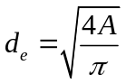，为平面物体的厚度。在长为宽为的矩形中，当截去较小面积区域时，为了简便，我们定义此时的圆形度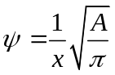，基于模型一得到的结论，圆形平底锅的受热要比不圆形状的.锅受热均匀些，由此，我们将用圆度来替代受热均匀度。
中间形状
如图所示是一个方形布朗尼平底锅，在加热烘烤食物时，存在四个角过热的情况，这是消费者不希望看到的。
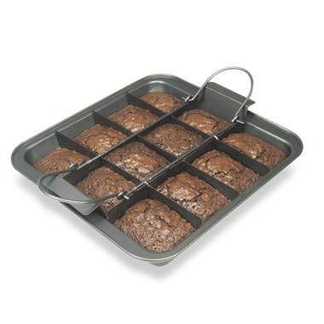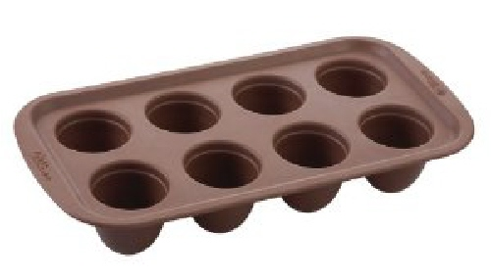
图五 图六
下图所示是一个圆形的布朗尼锅，优点是在其上加热食物时，食物各部分受热较均匀，加热出来的食物美观。缺点是平底锅上还有很多的空间没有得到充分的利用。

如下图所示，矩形MPQN的长PQ为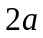，宽MP为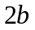，W与S为椭圆ACBD与矩形MPQN在第一象限的交点，W与S的横坐标分别为，(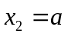)。WSQZZ’R’S’W’W为矩形和圆形之间中间形状。椭圆ACBD的方程为：
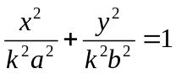

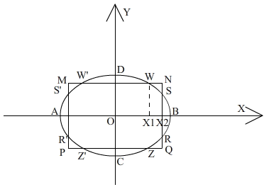

其中为大于0的待定参数，随着的变化WSQZZ’R’S’W’W的形状也是发生变化的。当的值为1时，WSQZZ’R’S’W’W就变成了一个椭圆，如果此时与的值相等，则WSQZZ’R’S’W’W蜕化为一个圆形。所以，用WSQZZ’R’S’W’W来表示矩形与圆形之间的过渡性形状是合理的。
设SX2的长度为，则中间形状的面积可以表示为：
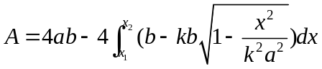
另外，由于点W和S均在椭圆上，将点W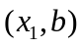与S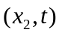代入椭圆方程可以得到以下等式：
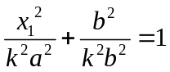
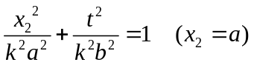
由此可以求得的表达式为：
模型的建立与求解：
在参考几家网上商店后，我们设定烤箱的结构尺寸如下：

L范围（0.25，0.5），W（0.15，0.3），a(0.0025,0.06),b(0.015,0.04),N1(1,10),N2(1,10),
最好的平底锅
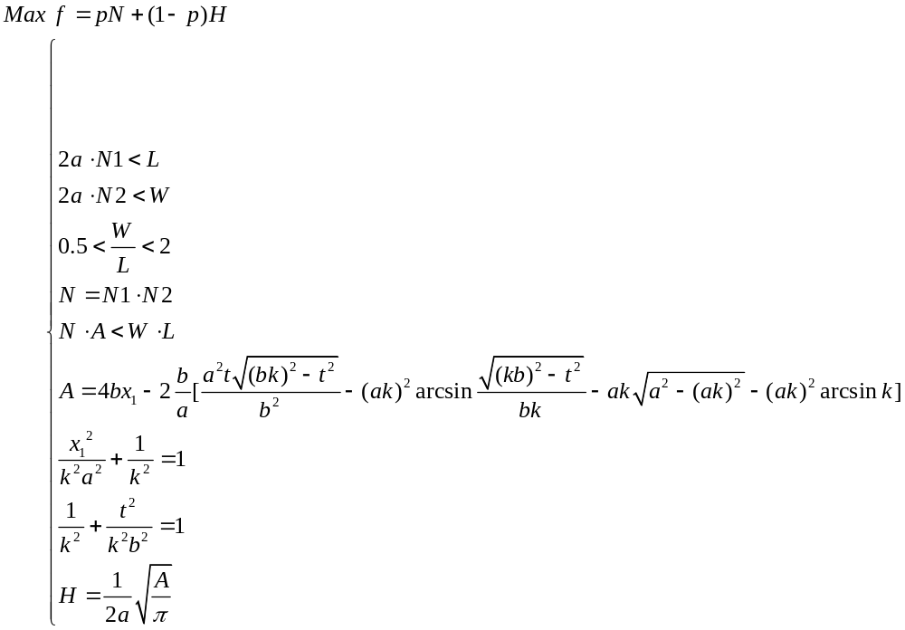
利用1stopt进行编程可以求得在发生变化时的变化情况如下表所示：

N | N1 | N2 | H | p | 1-p | W/L | f
6 | 6 | 1 | 3.05 | 0.1 | 0.9 | 0.775 | 3.345
15 | 3 | 5 | 2.66 | 0.2 | 0.8 | 0.654 | 5.128
10 | 2 | 5 | 2.33 | 0.3 | 0.7 | 0.588 | 4.631
18 | 9 | 2 | 2.92 | 0.4 | 0.6 | 0.586 | 8.952
16 | 2 | 8 | 2.43 | 0.5 | 0.5 | 0.915 | 9.215
21 | 3 | 7 | 2.76 | 0.6 | 0.4 | 0.839 | 13.704
24 | 6 | 4 | 4.32 | 0.7 | 0.3 | 0.993 | 18.096
21 | 7 | 3 | 1.79 | 0.8 | 0.2 | 1.786 | 17.158
18 | 3 | 6 | 3.62 | 0.9 | 0.1 | 0.618 | 16.562
通过上表可以看出，的最大值为18.096，权重系数的最佳取值为0.7。此时的W/L接近1，也就是说，最佳的匹配情况为平底锅的形状近似为正方形、烤箱的截面也近似为一个正方形。此时，大平底锅被划分为6×4共24个小平底锅。
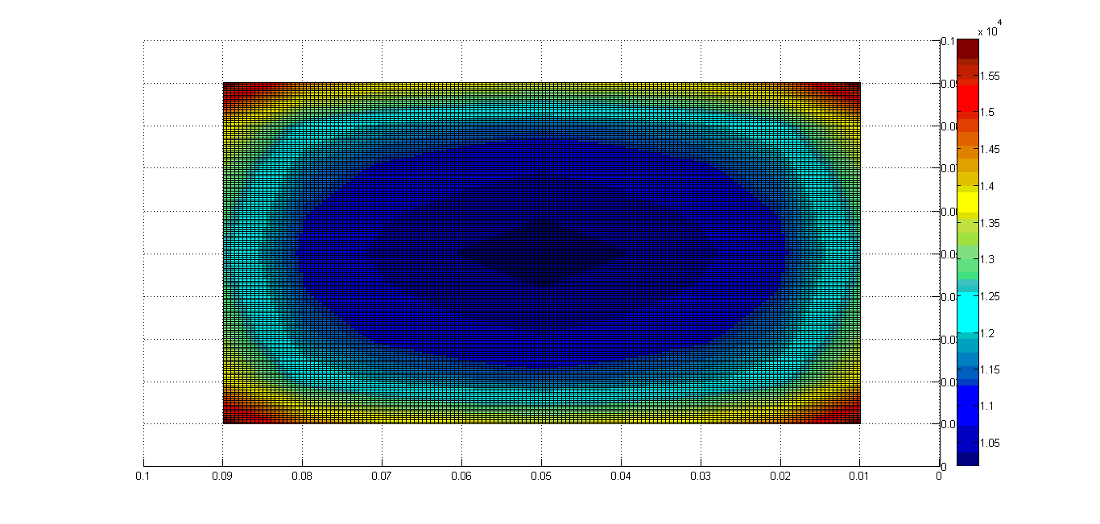

Model testing and sensitivity analysis
由于不同品牌的的烤箱的结构尺寸一般不相同，所以我们得到的最优的W/L不一定与顾客拥有的烤箱相符。我们的模型得到的最优的W/L只能用于设计配套的烤箱与平底锅时用得到。但是，当顾客仅需要购买的平底锅时，只需把他拥有的烤箱的结构尺寸告诉生产商，生产商便可利用我们建立的模型，为他选择最合适的平底锅。
由于不同品牌的的烤箱的结构尺寸一般不相同，所以我们得到的最优的W/L不一定与顾客拥有的烤箱相符。我们的模型得到的最优的W/L只能用于设计配套的烤箱与平底锅时用得到。但是，当顾客仅需要购买的平底锅时，只需把他拥有的烤箱的结构尺寸告诉生产商，生产商便可利用我们建立的模型，为他选择最合适的平底锅。
Since generally the structure sizes of ovens of different brands are not the same, the optimum W/L obtained is not necessarily fitting to that of the customer’s oven. The optimum W/L obtained by the model only works in designing matched ovens and pans. But, if the customer only needs to purchase a pan, as long as he informs the manufacturer of the structure size of his own oven, the manufacturer can therefore use the model built to select the most suitable pan for him.

Strengths and weaknesses discussion
优点：模型一根据自然界普遍存在的过程传递规律，首先研究了单层平壁热传导现象，然后将得到的结果用于三维热传递过程，得到了矩形、圆形以及两者之间的中间形状的受热情况。根据模型二，我们得到了既能使得产品受热均匀又能使得烤箱的空间得到充分利用的平底锅。
缺点：我们没有对热辐射对产品加热进行分析，也没有对不同的烤箱中的温度分布规律进行仔细的研究。
总的来说，我们建立的方法为最佳平底锅的设计问题提供了完整的解决方案。可以为生产商生产烤箱和平底锅提供有效的理论依据。
The advantages of the models: in the first model, in accordance with the process transfer law, the phenomenon of single flat wall heat conduction is studied in the first place, whose result is then used in the three-dimensional process of heat transmission. Eventually, the situation of heating in the objects of shapes of rectangular, circular and other shapes in between is explained. Under the instruction of the second model, the pan that is both capable of heating the product evenly and making full use of the space of the oven is thus designed.
The weakness of the models: there is a lack of analysis on thermal radiation’s heating the product, and a deliberate study on the rule of temperature distribution in different ovens is not realized.
Overall, the method established succeeds in providing a complete solution to designing the optimum pan, which can offer an effective theoretical basis for manufacturers to produce ovens as well as pans.

A devertisement sheet for the new Brownie Gourmet Magzine :
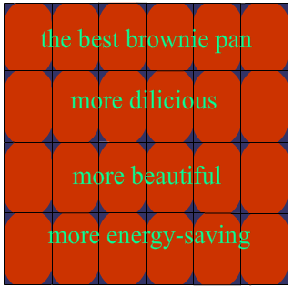
More dilicious more beautiful more energy-saving...
不聪明的主妇们，如果你想用最简单的brownie cake抓住你丈夫孩子们的胃，但是当你用传统的brownie pan 烘焙出烤焦的蛋糕时，你该用什么来弥补不美味的食物对他们造成的伤害，你又将如何重新建立起他们对于你可怜的厨艺的信心。But you know ,your lucky day is coming！在你还苦于如何精确调节烘烤时间的时候，不妨买个根据你的烤箱规格购买一个新的平底锅。
传统的平底锅由于外形设计的不合理经常导致产品出炉时，若烘烤时间过短，则局部过热的地方已经烤熟，而其它部位还没有熟，若烘烤时间过长，会造成局部产品烤焦的现象。由于烤箱的空间和能源没有充分利用，这对于节约的你来说也是个非常头痛的事情。
最近，我们团队为了设计一款烤箱匹配效果最佳的平底锅，最初了许多努力。最开始我们根据热传递过程速率与过程中的推动力成正比，与过程中的阻力成反比这一自然规律建立了传热过程的一维模型，然后将得到的结果类比到三维空间从而得到三维空间热传递的模型。通过这个三维传热模型，得到了圆形和矩形以及两者之间的中间形状的为综合考虑各种因素之后的平底锅的最佳形状。在结论一的基础上再考虑平底锅的摆放方式，基于圆形平底锅的热量分布最均匀这一认识，通过一系列非线性整数规划计算得到了当烤箱的长和宽之比W/L接近1时（0.993），烤箱中烘烤出的食物最美味，也最节省能源。
当然，对于食物来说，其外形美观也是一个值得考究的问题，我们设计的平底锅使用而不失美观，（下图可验证），对于懂生活又热爱生活的你来说绝对是最佳选择。

The pan designed according to our model is both aesthetic and symmetrical, which will avoid locally overheating the product in the oven thus overcooking it, in other words, to make the ripe product uniform in texture. On the premise that an even texture of the product is guaranteed, it is energy-saving and environmental-friendly to make use of the oven to the fullest.
For manufacturers, they can design the oven and the pan which are the best match by referring to our model.
For customers, they can choose the pan that is the fittest to their own oven once they are aware of the width and length of the oven. Meanwhile, the manufacturer is also able to inform the customers of the price of the pan (according to the manufacturing cost) for them to choose from.

